IMPORTANCE OF ON-SITE MACHINING DUE TO WELDING DISTORTION CAUSED WHILE FABRICATION OF HEAVY STRUCTURES
Prepared by
RIAZ AHMED BASHEER
Managing Director
Coren Technomech Private Limited- Bangalore.

Machining is a process by which the excess metal on raw material is removed to get the required dimensions and tolerances.
When it comes to Industries like shipbuilding, the massive structures of the ship known as blocks are fabricated to join together to form a hull. As the hull section of the ship is built, there is a distortion and undulations caused due to welding process of these structures. To achieve the accurate dimensional tolerance for installation of machinery outfit, Machine has to be done Onsite.
The machining location and the dimensions of the structure being large in size, these locations are to be machined Onsite using Portable Machine tools.
Based on the location to be machined along with the constraints and the obstructions, the appropriate portable machine tools are selected.
In general, the portable machine tools are categorised as:-
- Portable Line Boring Machines
- Portable 3 Axis Gantry / Linear Milling Machines
- Portable Circular Milling Machines
- Portable Heavy Duty Drilling Machines etc.
The main applications which demand Onsite Machining using Portable Machine tools are
- Main Engine Beds / Foundations
- Stern Tube / A Brackets / Rudder bores
- Gun Mounting Turrets
- Machine Gun Bores
- Brahmos Launcher Foundations
- Sonar Dome Flange
- Radar Foundations etc.
The equipment being selected for Onsite machining for any onboard application must be compact in size, easy to handle and importantly, should deliver the post machining Dimensional tolerances and accuracy as per the drawings of the Shipbuilding OEM.
The most important aspects which decides the above are :-
- The Design and Construction of the equipment as per International Standards
- The Qualified and skilled technicians to operate the equipment.
If in case Shipyard carryout Onsite machining by themselves, the following factors are to be considered.
- The Portable Machining tool should be from a reputed manufacturer & user friendly.
- The equipment should have designed as per international standards
- The equipment and its critical components should be precision and high accuracy.
If in case the Shipyard carryout Onsite machining through a service contractor, the following factors are to be considered.
- In addition to the above 3 factors, the equipment operator must be qualified and skilled.
- The service company must have adequate back up for manpower or spares for the equipment if in case of any break down
- The contract company should have good experience and track record for having delivered successful jobs in the past.
- The contact company should have knowledge of designing jigs / fixture to accommodate the portable machine tools without damaging the fabricated structure.
- The contract company should be capable to understand the losses / consequences of poor delivery / damage of the job due to poor quality equipment or un-skilled manpower.
So, whenever there is any machining to be carried out on the heavy structures, Onsite Machining is the only Choice.
In addition to Ship building Industry, there many other heavy structures need Onsite Machining like :- Usually the large jobs are reffered as
- Large fabricated structures,
- Crane towers,
- Heat Exchangers / Reactors
- Floating windmill towers
- Offshore platforms
- FPSO’s
- Mining / Earth moving equipments etc
The following pictures gives and idea about large jobs/ strucutres / equipmnets which are difficult to move to the machine shops.
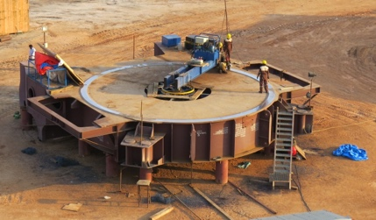 | 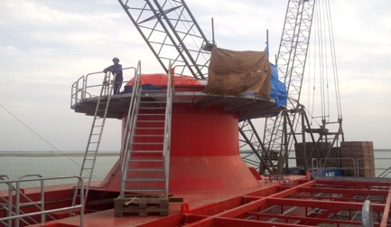 | 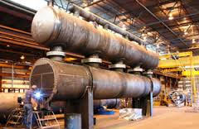
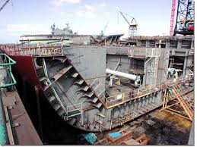 | 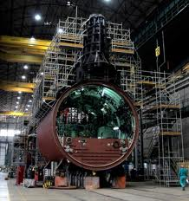 | 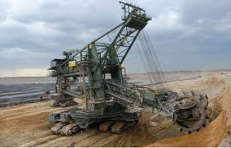

Industry and their Nature of Job
S.No | Industry | Nature of Work / End Product
01 | Steel Plants | Manufactures steel in the form of Plates, Rods, Sheets, Beams etc from the Iron ore.
02 | Ship Building / Ship Repairs | Manufacture of New ships (Naval, Oil Tankers, passenger, Cargo) Repairing of existing ships.
03 | Shipyard | Place where the ships berth for loading, Un loading & repair. Shipyards should have the heavy material handling systems like Huge cranes, Ship lift systems.
04 | Mining | There are different kinds of Mining like Coal, Iron ore, Copper order, Aluminium Ore, Lignite, Minerals, Granite etc. The onsite machining applications exists in the equipment which is used for mining.
05 | Cement Plant, Thermal Power Plant, Wind Mill Manufacturer, | The would have lot of equipment which are large in size and would undergo wear and tear. As they cannot shutdown the plant for long, these industries always prefers to invite onsite service companies to work at their site.
06 | Oil and Gas | These industries design n manufactures large structures which are taken off shore for the oil extraction. Usually, these structures are attached to large ships and taken to oil drilling location.

