Assessing the Accuracy of Simulated Models against Experimental Observations in Hybrid Laser Arc Welding

Visal Gopi¹  vishalgopi07@gmail.com | Dr. Krishna Prasad S²  krishnaprasad.s@cochinshipyard.in | Syamkumar V³  Syamkumar.v@cochinshipyard.in

Abstract - Hybrid Laser Arc Welding (HLAW) synergizes the deep penetration of laser welding with the gap-filling adaptability of Gas Metal Arc Welding (GMAW), enabling high weld speeds, reduced distortion, and superior joint quality. Understanding macro structural characteristics—such as weld bead geometry, penetration depth, heat-affected zone (HAZ) width, and fusion line integrity—is crucial for ensuring weld soundness. This study employs a Welding software to simulate and analyse the macrostructure of HLAW butt and fillet welds. The objectives are to predict weld pool behaviour, solidification patterns, and macro structural features, while evaluating the effects of laser-arc energy ratios, welding speed and joint geometry. A coupled thermal-mechanical solver models temperature distribution and molten pool dynamics, with standard boundary conditions. Experimental validation involves macro-etching weld coupons and analysing cross-sections using optical stereomicroscopy for weld bead width, penetration depth, and HAZ size. Expected outcomes include visualization of keyhole formation, fusion boundaries, and thermal gradients, identification of optimal energy ratios for defect-free welds, and comparative macrographs highlighting joint configuration effects. This work underscores the value of software based virtual prototyping in predicting macro structural outcomes, reducing physical trials, and enhancing weld quality for shipbuilding, automotive, and aerospace applications.

Index Terms - Hybrid Laser Arc Welding, Macrostructure, Keyhole, Weld Simulation
INTRODUCTION
Hybrid Laser Arc Welding (HLAW) combines the benefits of laser and arc welding to achieve superior performance compared to either process alone. The precise control over heat input and filler addition enables high-quality joints in structural materials like aluminium and mild steel. Accurate prediction of weld characteristics through simulation tools allows engineers to optimize process parameters, reducing experimental effort and improving quality assurance in shipbuilding, automotive, and aerospace applications.

METHODOLOGY
This study integrates numerical simulation and experimental validation to analyse the macro structural characteristics of Hybrid Laser Arc Welding (HLAW) joints. The overall workflow is illustrated in FIGURE 1

FIGURE 1. WORK FLOW
A thermo-coupled mechanical model was developed using welding simulation software, SIMUFACT WELDING to analyse temperature distribution, molten pool dynamics, and thermal gradients during the HLAW process. The model incorporated standard boundary conditions including convective and radiative heat losses. Material properties such as thermal conductivity, specific heat, and absorptivity were selected as temperature-dependent parameters. Experimental trials were performed using mild steel and aluminium alloy plates under varying energy ratios and welding speeds to validate the simulated results. Macro-etching and optical microscopy techniques were used to observe weld penetration, bead geometry, and HAZ width.

- Materials and Joint Configurations
This study was conducted on two distinct material systems, marine-grade steel (AH36) and aluminium alloy (AA 5083-H116) to evaluate the macro-structural characteristics of Hybrid Laser Arc Welding (HLAW) in both ferrous and non-ferrous applications. The selection of these alloys was based on their extensive use in shipbuilding, offshore, and structural fabrication industries, where weld quality and distortion control are of critical importance.
For each material, two weld joint configurations were examined:
- Butt joint configuration, representing plate-to-plate joining in hull and structural panels.
- Fillet joint configuration, representing T-type or corner assemblies typical in stiffener and frame structures.
The AH36 steel specimens were prepared using a plate of thickness 7 mm, while the AA 5083-H116 aluminium alloy specimens had a thickness of 4 mm. Each plate measured 350 mm × 150 mm. Prior to welding, all specimens were mechanically ground along the joining surfaces to remove oxides and surface irregularities. For the butt welds, an inlet and outlet plate were tacked on to prevent the plates from opening during welding. The joint edges were aligned and clamped firmly to maintain uniform gap and minimize distortion during the welding process. For fillet welding the T-Joints were also tacked to the base plates to prevent warping.

- Welding machine used for the trails
The welding system used in this study was a fully automated Fronius LaserHybrid system, configured with an iWave 500i power source, a cooler CU 1400i Pro/MC and a 25i LaserHybrid 10kW/W wire feeder. The motion of the welding head was governed by a six-axis robotic arm allowing accurate and repeatable positioning throughout the weld path.

- Welding Setup of HLAW welding
The hybrid laser–GMAW system configured in a laser-leading arrangement, where the laser beam preceded the arc torch by a distance as shown in FIGURE 2. This configuration was selected to promote keyhole stability and effective coupling between the two heat sources, thereby improving penetration depth and weld bead uniformity.
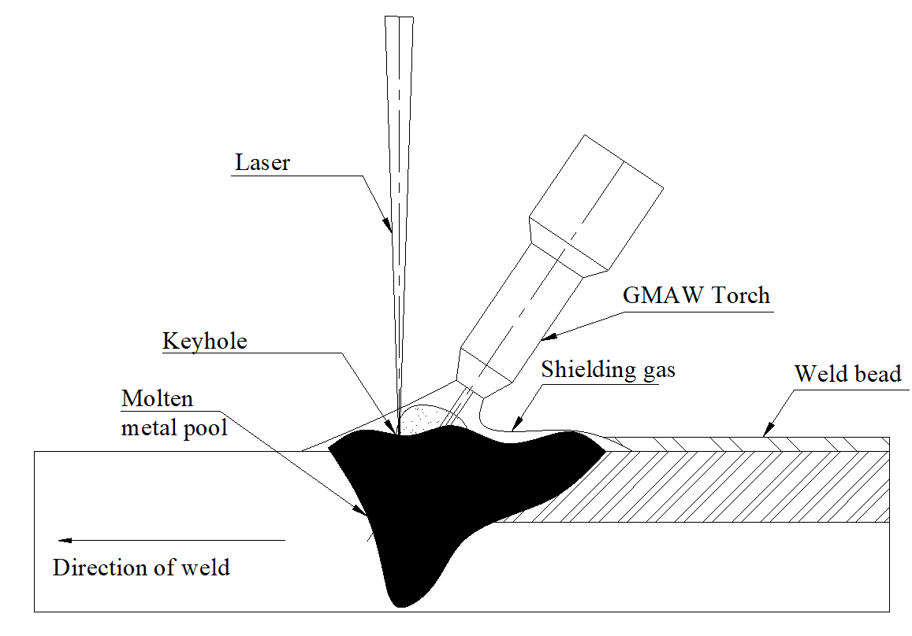
FIGURE 2. HLAW OVER VIEW

- Welding Parameters for AH36 Steel (7 mm) Butt weld
Welding trials for the AH36 steel plates were conducted using the parameters summarized in Table 1. The ER70S-6 filler wire (1.2 mm diameter) was employed under M20 Ar+5-10%CO₂ shielding gas. The weld setup is depicted as in FIGURE 3 and Laser-Arc configuration is represented in FIGURE 4. The edges were milled for butt welding configuration and the plates were positioned at 0 mm root-gap for welding.

TABLE 1 HLAW WELDING PARAMETER USED FOR AH36 STEEL, BUTT WELD 7mm.
Parameter | Range / Setting
Voltage | 21 V
Current | 157 A
Welding Speed | 150cm/min
Shielding gas | M20 Ar+5-10%CO₂
Wire | ER70S-6
Wire feed speed | 5.5m/min
Welding speed | 150cm/min
Seam length | 350mm
Laser power | 7 KW
Laser Focus position | 2mm
Laser Focal length | 300
Fibre diameter | 0.3mm
Root gap | 0 mm
Distance laser - wire | 4mm
Laser diameter | 0.45mm

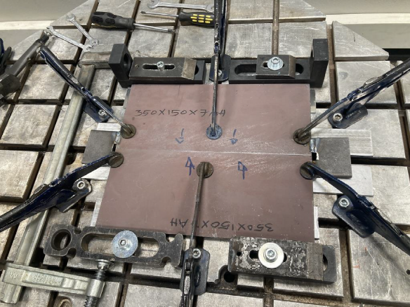
FIGURE 3. WELD SETUP – AH36 STEEL BUTT JOINT (7mm)

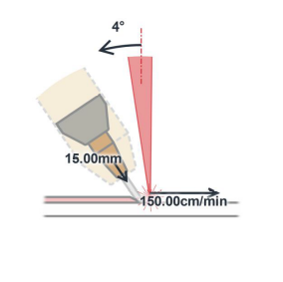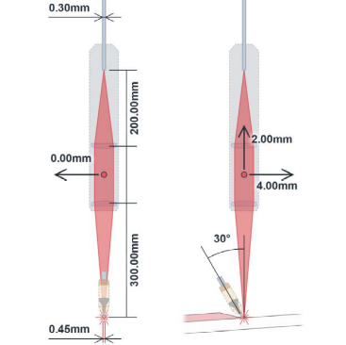
FIGURE 4. GMAW – LASER CONFIGURATION FOR AH36 STEEL (7mm) BUTT JOINT

- Welding Setup of HLAW welding head in SIMUFACT WELDING software - AH36 STEEL (7mm) BUTT JOINT
The hybrid laser–arc welding (HLAW) simulation was developed to accurately replicate the actual welding conditions applied to AH36 steel butt joints. Initially, a three-dimensional model of the welded specimen was prepared using a SOLIDWORKS 2023, 3D modelling software, representing the exact geometry of the experimental setup, including the 350 mm × 150 mm × 7 mm plate dimensions and joint configuration. This geometric model was then imported into the SIMUFACT WELDING 2025.2, welding simulation software for subsequent thermal and thermo-mechanical analyses. Appropriate boundary conditions were applied to reproduce the real welding environment, including fixed constraints (FIGURE 5) at the clamped edges and free convection and radiation conditions on exposed surfaces. Material properties of AH36 STEEL were applied from the material library of the software. The process parameters such as laser power, arc current, welding speed, and laser–arc separation was defined to match those used in the physical welding trials, ensuring realistic correlation between the simulated and experimental cases.

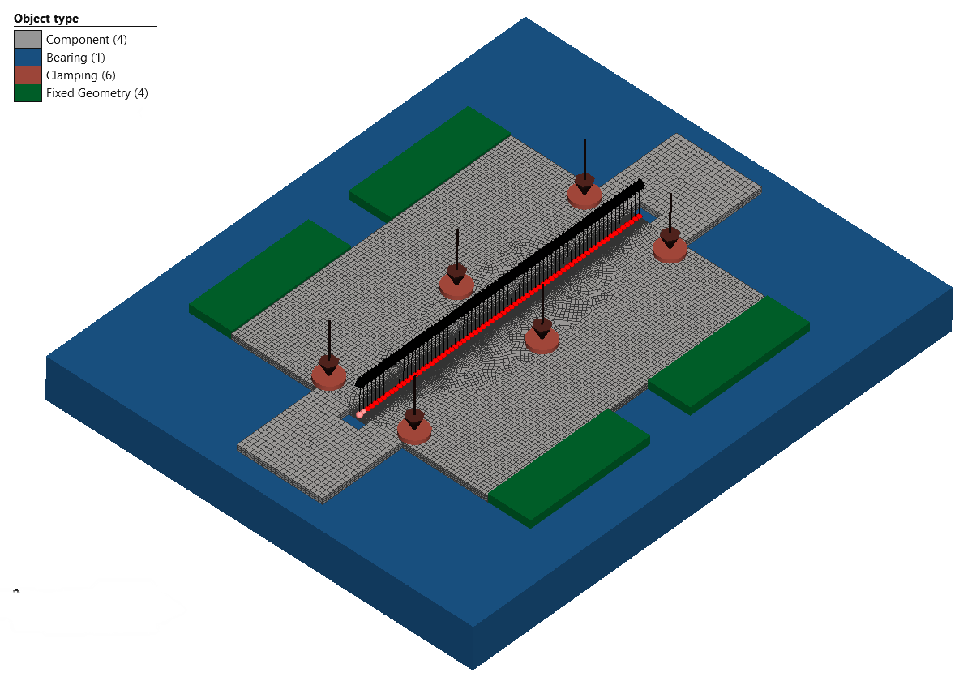
FIGURE 5. 3D MODEL WITH BOUNDARY CONDITON FOR AH36 STEEL (7mm) BUTT JOINT
A finite element mesh was generated for the model (FIGURE 6), with particular attention to the weld region. To optimize computational efficiency, fine meshing was applied along the weld zone and fusion line to accurately capture thermal gradients and molten pool behaviour during the transient thermal analysis.
Once the thermal model was validated, a coarser mesh was adopted for the thermo-mechanical analysis to reduce simulation time while maintaining sufficient accuracy for stress and distortion evaluation. The same methodology was used to do other configurations & simulations.
The heat source was modelled using a Goldak double-ellipsoidal volumetric heat distribution representing the GMAW and Gaussian conical model heat source (FIGURE 7) were used to represent the laser heat source, which effectively represents the non-uniform energy input typical of hybrid welding processes. The correctness of the same will later be established during the comparison with the macrostructure of the welded specimen.
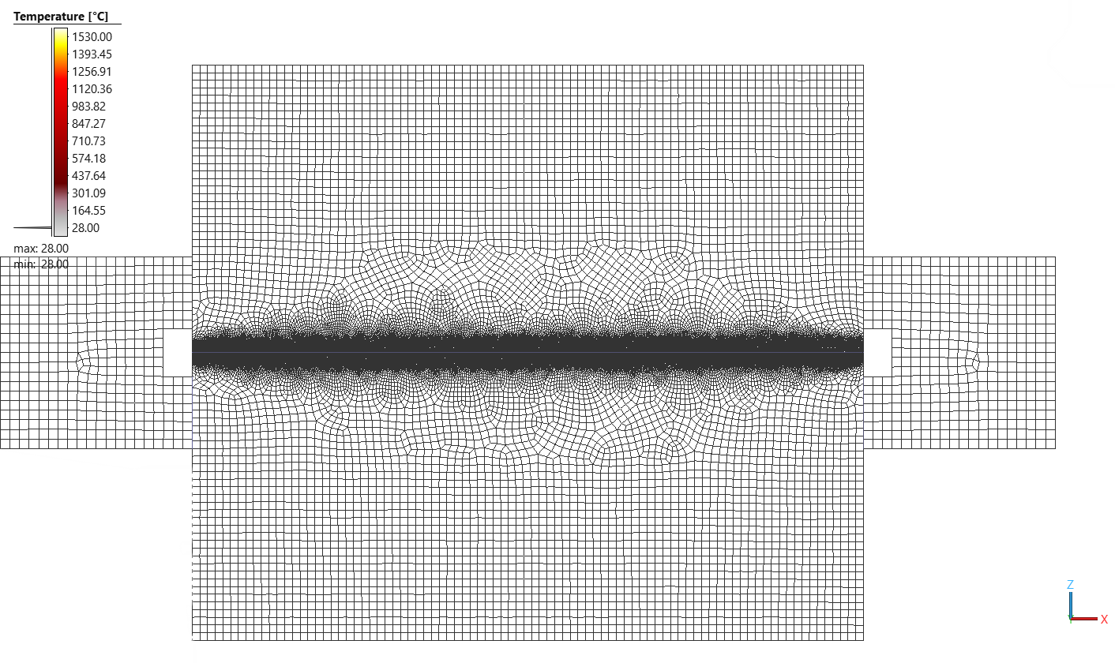
FIGURE 6. MESHING OF 7mm AH36 STEEL
The spatial orientation and angular alignment between the laser beam and GMAW torch were replicated exactly as in the physical welding setup, maintaining the same laser-leading configuration and separation distance. This ensured realistic simulation of the hybrid interaction zone and accurate prediction of the resulting thermal field and fusion characteristics.
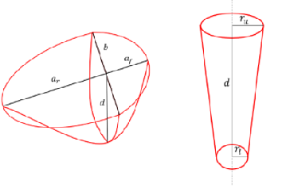
FIGURE 7. REPRESENTATION OF HEAT SOURCE MODEL FOR GMAW & LASER
The simulation was performed with the same parameter of laser and arc power levels and welding speeds to analyse the weld macrostructure. The simulation generated a temperature field profile and predicted weld pool geometry, including bead width, penetration depth, and heat-affected zone (HAZ) dimensions. Post-processing analysis provided insight into keyhole formation, fusion boundary evolution, and solidification patterns under varying process conditions. The scope of the paper is limited to the analysis and comparison of the keyhole formation and shape of hybrid laser arc weldment produced using simulation and physical welding.
- Welding Parameters for AH36 Steel (7 mm) Fillet weld
Welding trials for the AH36 steel plates were conducted for fillet weld using the parameters summarized in Table 2. The ER70S-6 filler wire (1.2 mm diameter) was used with M20 Ar+5-10%CO₂ shielding gas. The weld setup for this experiment is shown in FIGURE 8 followed by the configurations in FIGURE 9.
TABLE 2. HLAW WELDING PARAMETER USED FOR AH36 STEEL, FILLET WELD 7mm.
GMAW Parameter | Range / Setting
Voltage | 21.8 V
Current | 192 A
Welding Speed | 125cm/min
Shielding gas | M20 Ar+5-10%CO₂
Wire | ER70S-6
Wire feed speed | 7.0m/min
Welding speed | 125cm/min
Seam length | 350mm
Laser power | 7 KW
Focus position | 2mm
Focal length | 300
Fibre diameter | 0.3mm
Rootgap | 0.75 mm
Distance laser - wire | 4.5mm
Laser diameter | 0.45mm

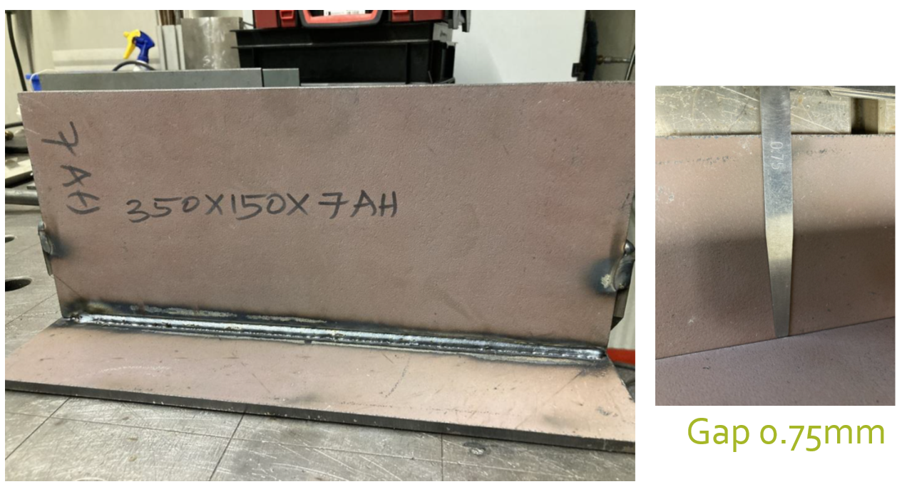
FIGURE 8. WELD SETUP – AH36 STEEL FILLET JOINT (7mm)

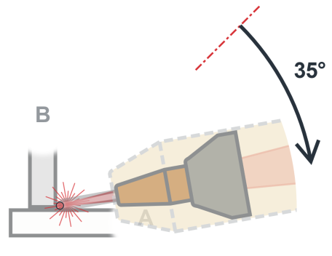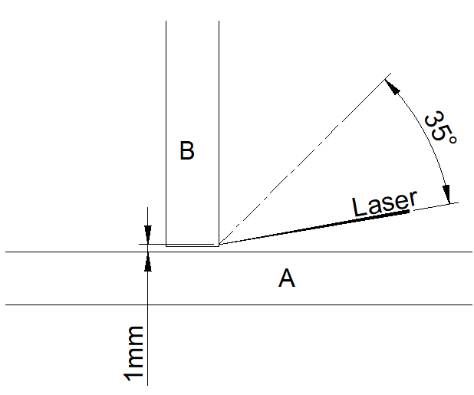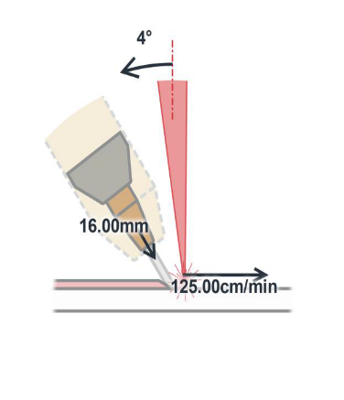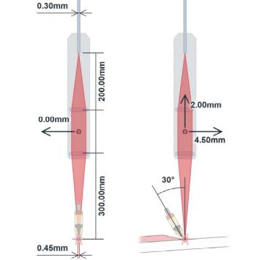
FIGURE 9. GMAW – LASER CONFIGURATION FOR AH36 STEEL (7mm) FILLET JOINT

- Welding Setup of HLAW welding head in simulation software - AH36 STEEL (7mm) FILLET JOINT
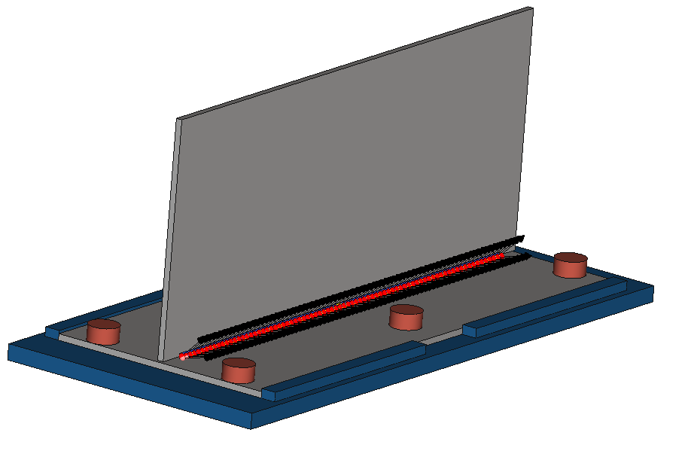
FIGURE 10. 3D MODEL WITH BOUNDARY CONDITON FOR AH36 STEEL (7mm) FILLET JOINT
A three-dimensional model of the weld setup (Figure 10) was developed using modelling software, replicating the geometric parameters of the actual experimental configuration. The model was subsequently imported into the simulation software, where appropriate boundary conditions, including clamping constraints and thermal loading, were applied based on data obtained from the material database. A refined mesh was generated in the vicinity of the weld zone to ensure higher accuracy in temperature and stress predictions during the simulation.

- Welding Parameters for & AA 5083-H116 (4 mm) Fillet weld
Welding trials for the AA 5083-H116 (4 mm) were conducted using the parameters summarized in Table 3. The AWS: ER 5356filler wire (1.2 mm diameter) was employed under I1 100% Ar shielding gas. The FIGURE 11 shows the weld setup and FIGURE 12 represent the weld configuration used for this experiment.
TABLE 3. GMAW - WELDING PARAMETER USED FOR AA 5083-H116, FILLET WELD 4mm.
GMAW Parameter | Range / Setting
Voltage | 18.8 V
Current | 130 A
Welding Speed | 125cm/min
Shielding gas | I1 100% Ar
Wire | AWS: ER 5356
Wire feed speed | 7.5m/min
Welding speed | 125cm/min
Seam length | 350mm
Laser power | 6 KW
Focus position | 5mm
Focal length | 300
Fibre diameter | 0.3mm
Distance laser - wire | 4.5mm
Laser diameter | 0.3mm

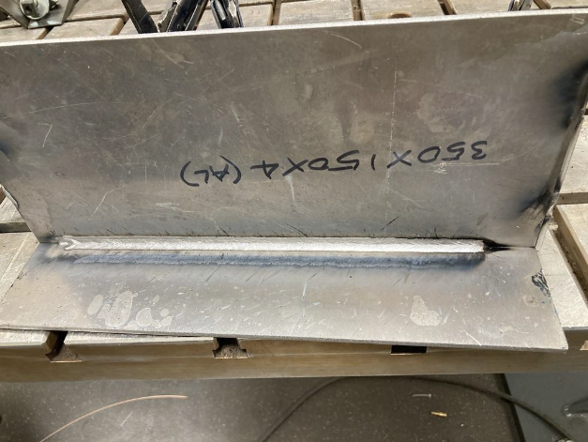 FIGURE 11. WELD SETUP – AA 5083-H116 FILLET JOINT (4mm)

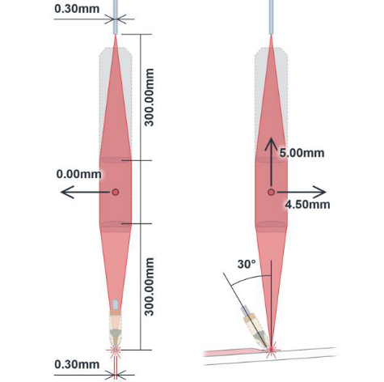
FIGURE 12. GMAW – LASER CONFIGURATION FOR AA 5083-H116 (4 mm) FILLET JOINT

- Welding Setup of HLAW welding head in simulation software - AA 5083-H116 (4mm) BUTT JOINT
Figure 13 presents the three-dimensional model constructed for the welding simulation of the AA 5083-H116 butt joint. The model was subsequently imported into the simulation environment, where meshing was performed to discretize the domain prior to conducting the thermal–mechanical simulation.
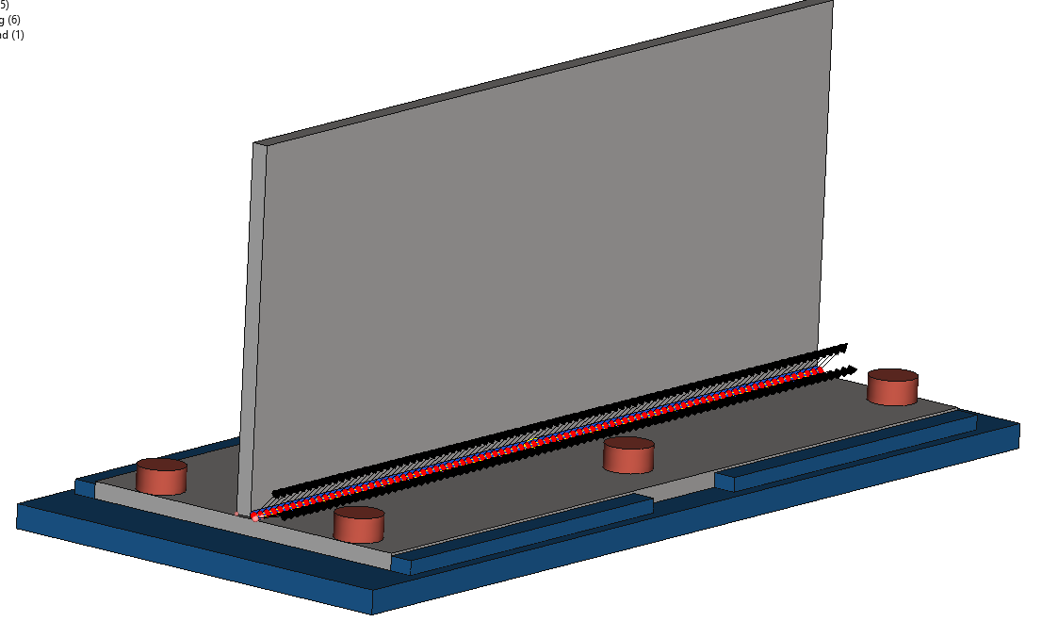

FIGURE 13. 3D MODEL WITH BOUNDARY CONDITON FOR AH36 STEEL (7mm) FILLET JOINT

RESULTS AND VALIDATION
- Experimental validation - Macro structural Examination
Experimental trials were conducted under the same parameter conditions mentioned in Table 1-3 in the weld setup. Weld coupons were sectioned, ground to level up, cleaned and macro-etched using standard metallographic procedures, Keller’s reagent for aluminium and 2% Nital solution (a mixture of nitric acid and ethanol) was used as the etchant to develop the macrostructure. The etched surfaces were examined to evaluate bead geometry, fusion line integrity, and Heat Affect Zone (HAZ).
Macro photographs were taken to examine bead geometry, fusion line integrity, and HAZ boundaries.
The macrographs depict the formation of keyhole fusion zone due the laser deep penetration and wider field of fusion zone due GMAW as shown in FIGURE 15, 17 & 19.
- Software Simulation results
The thermal–mechanical simulation was carried out using experimentally obtained welding parameters from the actual Hybrid Laser Arc Welding (HLAW) trials on AH36 steel & AA 5083-H116 for different configurations (FIGURE 4, 9 &12). The objective of the simulation was to replicate the real process conditions and analyse the corresponding temperature distribution and thermal behaviour. The model reproduced the transient temperature fields observed during welding, showing peak temperature zones concentrated along the laser beam axis, with heat rapidly dissipating into the adjacent arc-affected regions. The laser heat source predominantly governed the penetration profile, while the arc component contributed to lateral heat spreading.
In the laser-dominant energy mode, the simulation indicated a narrower yet deeper fusion zone, whereas under arc-dominant conditions, the weld profile became wider with shallower penetration. Thermal cycle data extracted at critical locations specifically at the fusion boundary, mid-heat-affected zone (HAZ), and base metal demonstrated that laser-arc energy combination resulted in shorter heating and cooling durations as shown in FIGURE 14, 16 &17. 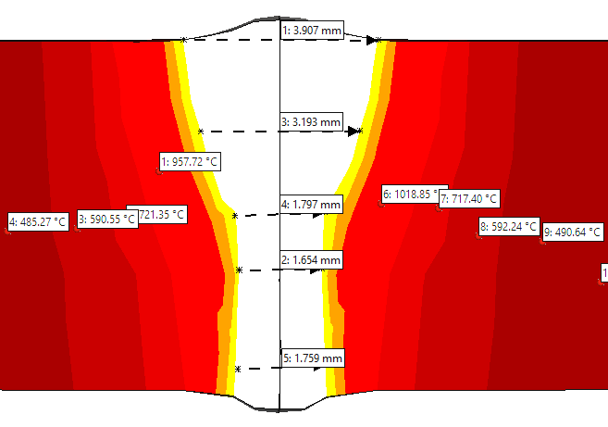 FIGURE 14. COMPARISON OF HLAW ON AH36 STEEL 7mm – BUTT WELD MACRO STRUCTURE vs SIMULATION RESULT

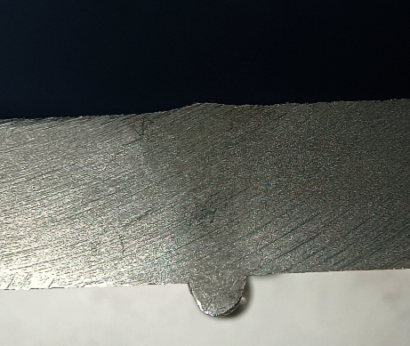
4.6mm
1.4mm
Fusion
HAZ
Base metal
2.2mm
7mm
FIGURE 15. MACROGRAPH OF HLAW ON AH36 STEEL 7mm – BUTT WELD MACRO STRUCTURE vs SIMULATION RESULT

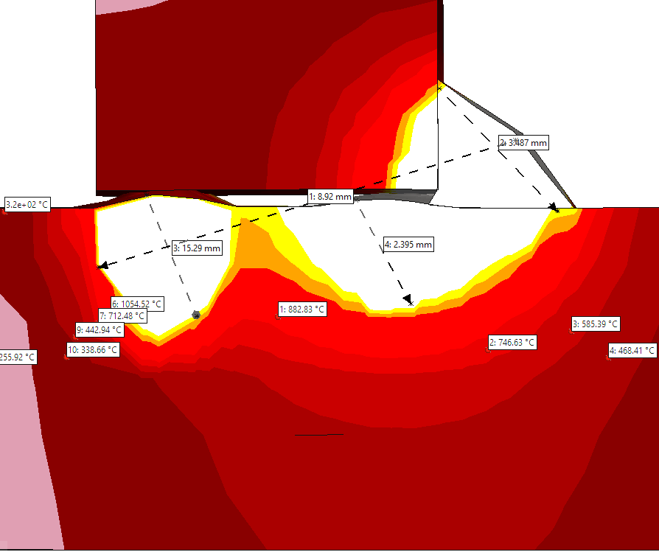
FIGURE 16. SIMULATION RESULT OF HLAW ON AH36 STEEL 7mm – BUTT WELD MACRO STRUCTURE vs SIMULATION RESULT

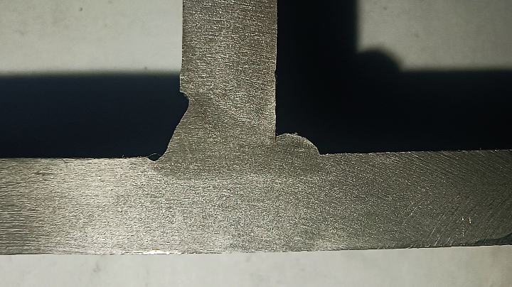
5.1mm
10mm
2mm
HAZ
Base metal
3mm
1.5mm
Fusion
7mm
FIGURE 17. MACROGRAPH OF AH36 STEEL, 7mm – FILLET WELD MACRO STRUCTURE vs SIMULATION RESULT

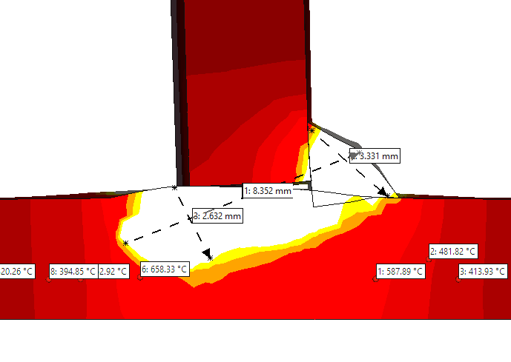
FIGURE 18. SIMULATION RESULT OF AA 5083-H116, 4mm – FILLET WELD MACRO STRUCTURE vs SIMULATION RESULT

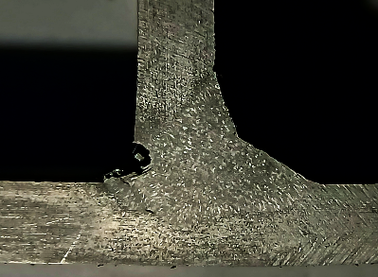
7.2 mm
Base metal
HAZ
7.85mm
Fusion
4mm
FIGURE 19. MACROGRAPH OF AA 5083-H116, 4mm – FILLET WELD MACRO STRUCTURE vs SIMULATION RESULT

The comparison demonstrated that the simulation effectively captured the key features of the welds, including bead shape, penetration profile, and thermal distribution. Replicating the laser-to-arc energy ratios and welding speed were found to significantly influence weld pool behaviour and HAZ characteristics, and the simulation effectively predicted these effects.

CONCLUSION
The simulated weld profiles were analysed and compared with experimentally obtained macrostructures, fusion line integrity, and the extent of the heat-affected zone (HAZ). The close agreement between the experimental observations and simulation results confirms that the developed numerical model can reliably replicate real welding behaviour and accurately predict macrostructural responses. Although the present methodology incorporated experimental data to establish and validate the simulation model, this approach was undertaken as a one-time validation exercise to verify the model’s predictive capability. ss
The comparative data obtained from this study can be utilized to further calibrate the simulation model, thereby enhancing its accuracy and ensuring closer alignment with actual welding outcomes. Once validated and calibrated, such simulation tools can be effectively employed for process optimization, parameter refinement, and reduction of extensive physical trials, contributing to the realization of high-quality, defect-free welds in industrial applications.

REFERENCES

- Hao, Kangda, et al. "Effect of heat input on weld microstructure and toughness of laser-arc hybrid welding of martensitic stainless steel." Journal of Materials Processing Technology 245 (2017): 7-14.

- Petring, D., et al. "Investigations and applications of laser-arc hybrid welding from thin sheets up to heavy section components." International Congress on Applications of Lasers & Electro-Optics. AIP Publishing, 2003.

- Liu, Shuangyu, et al. "Analysis of droplet transfer mode and forming process of weld bead in CO2 laser–MAG hybrid welding process." Optics & Laser Technology 44.4 (2012): 1019-1025.

- I. N. Shiganov, A. I. Misyurov, A. N. Trushnikov, A. A. Kholopov, and V. V. Blinkov, “Hybrid laser–arc welding of aluminium alloys,” Welding International, vol. 31, no. 1, pp. 67–70, 2017, doi:

- Nilsson, Klas, et al. "Parameter influence in CO2-laser/MIG hybrid welding." Annual assembly of International Institute of Welding: 06/07/2003-10/07/2003. 2003.

- Churiaque, Cristina, et al. "Laser hybrid butt welding of large thickness naval steel." Metals 9.1 (2019): 100.

- Tsubota, Shuho, et al. "Laser Welding System for Various 3-D Welding-Development of Coaxial Laser Welding Head." Laser 5 (2005): 1

